Fitness and Health Index Calculators
Built using HTML, CSS, JavaScript Anthony Wang

Home page of the fitness and Health Index Calculators
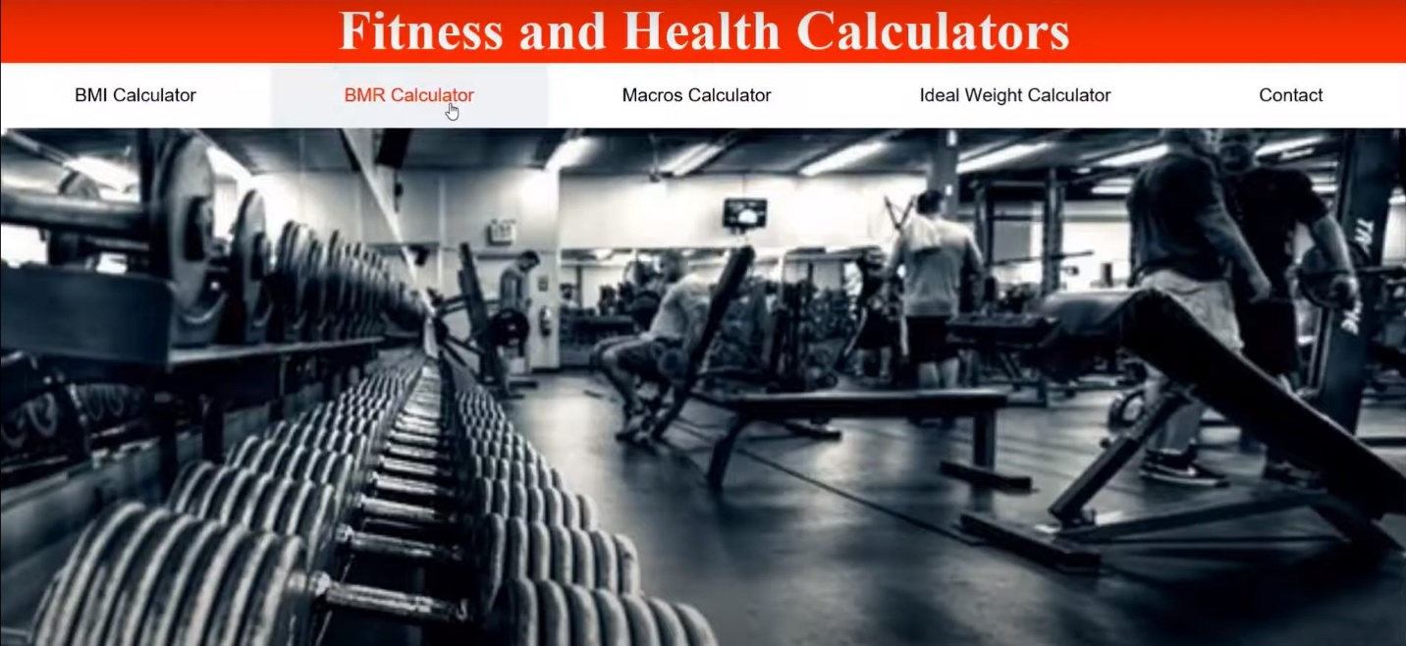

This website provides essential tools for understanding key aspects of health and fitness. Key aspects include body mass index, basal metabolic rate, macronutrient distribution and ideal weight. Each calculator offers insights to support fitness goals and embedded videos to explain different terminologies and concepts.

BMI Calculator
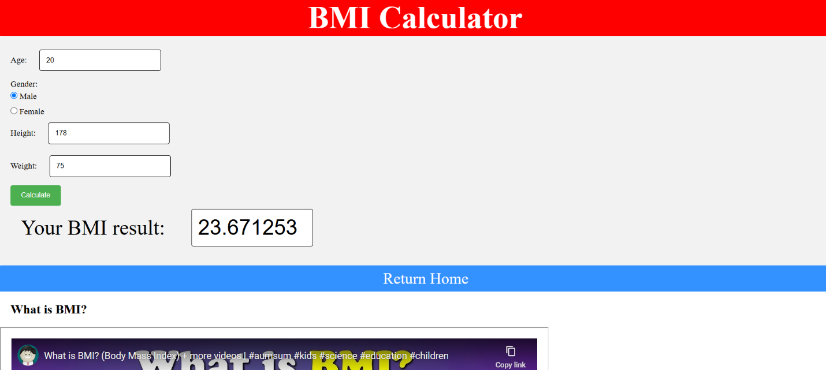
The Body Mass Index (BMI) is a measurement that assesses your weight relative to your height. It helps categorize individuals into weight categories that can help indicate potential health risks. BMI is a simple, quick and easily accessible calculation tool. However, it is not perfect, a big reason is that a person with lots of muscle and minimal body fat can have the same BMI as a person with obesity who has much less muscle.

BMI is calculated using this formula:
​$BMI= \frac{weight in kilograms}{{(height in meters)}^{2}}$

Based on your score, it will classify you as underweight, normal weight, overweight, or obese, using standard categories established by health organizations.

BMR Calculator
Basal Metabolic Rate (BMR) represents the number of calories your body needs at rest to maintain vital functions, like breathing and digestion. It’s an essential starting point for calculating daily calorie needs.

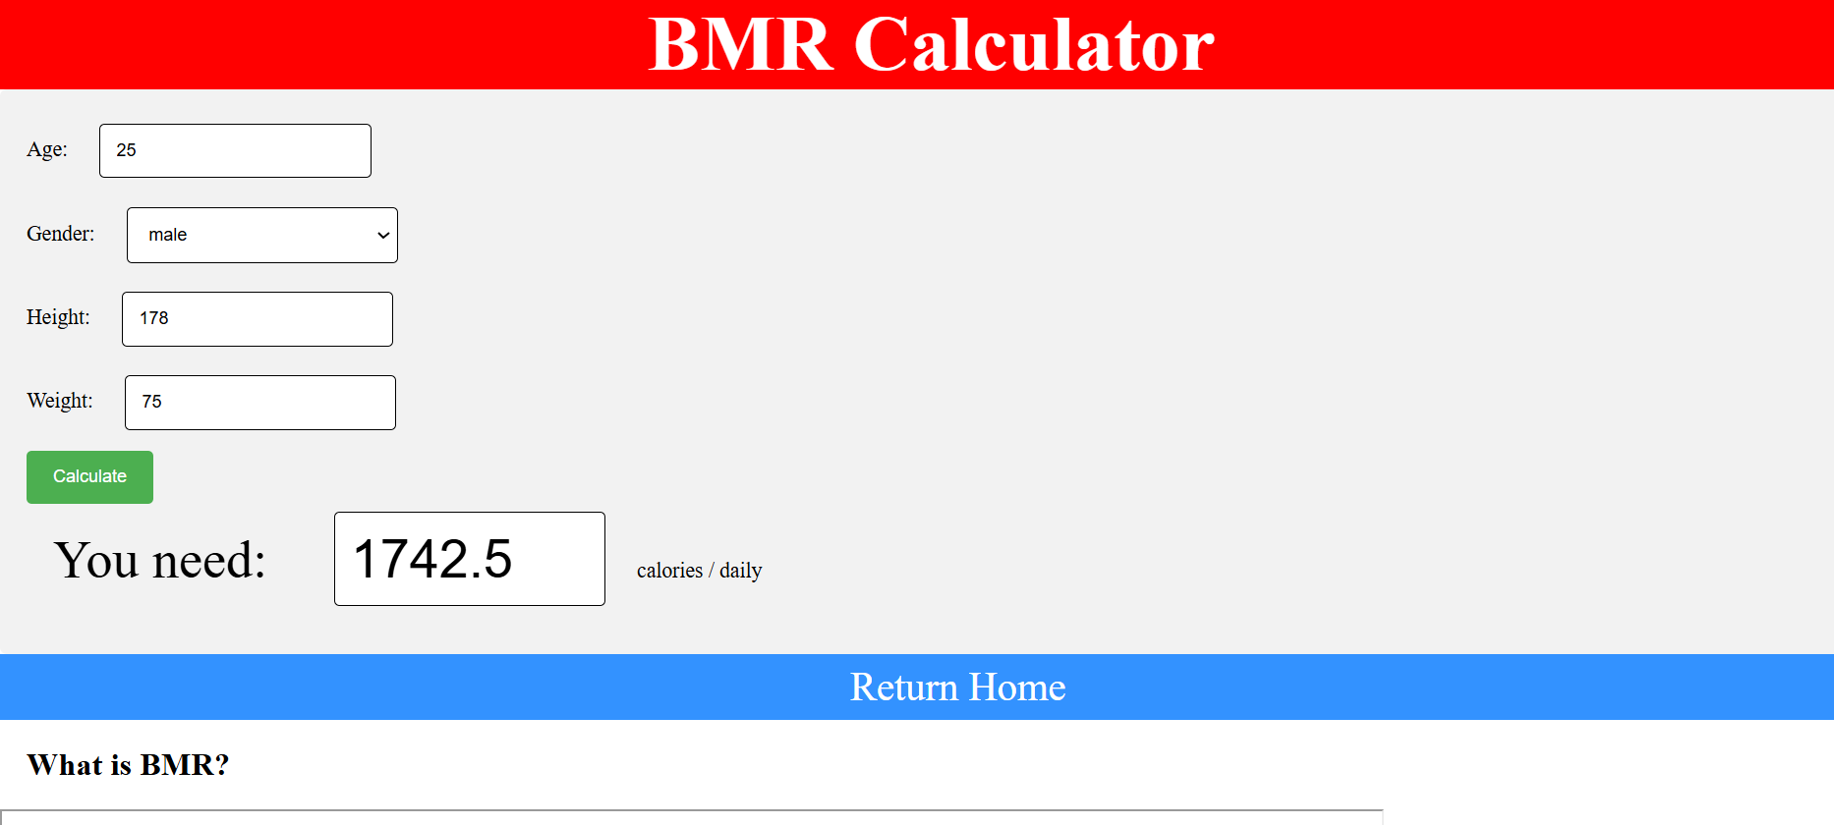

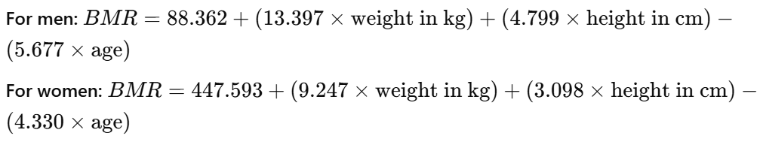
Formula: The Harris-Benedict or Mifflin-St Jeor equations are commonly used to determine BMR, taking into account users’ weight, height, age, and gender:

This calculator allows users to understand their baseline calorie needs and adjust your intake based on activity level.

Macros Calculator
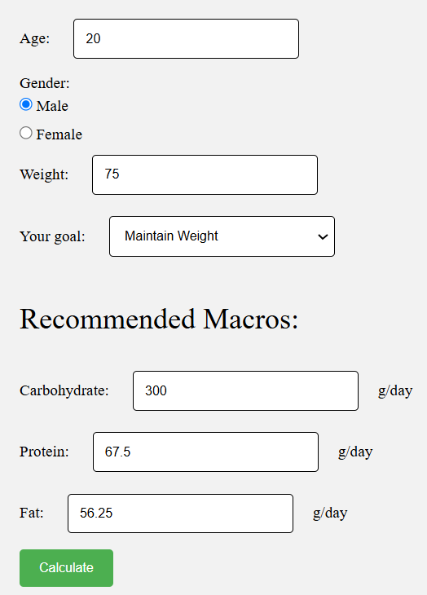
A Macronutrient or Macros Calculator helps yousersu determine the optimal distribution of macronutrients (proteins, carbohydrates, and fats) in their diet. Knowing macros can help users target specific fitness goals, like muscle gain, maintaining or fat loss.
The recommended macro ratios vary:
- For maintenance:
30% protein, 40% carbs, 30% fat
- For weight loss:
35% protein, 25% carbs, 40% fat
- For muscle gain:
40% protein, 40% carbs, 20% fat
The amount of protein intake increases significantly if the goal is muscle gain and weight loss.

Ideal Weight Calculator
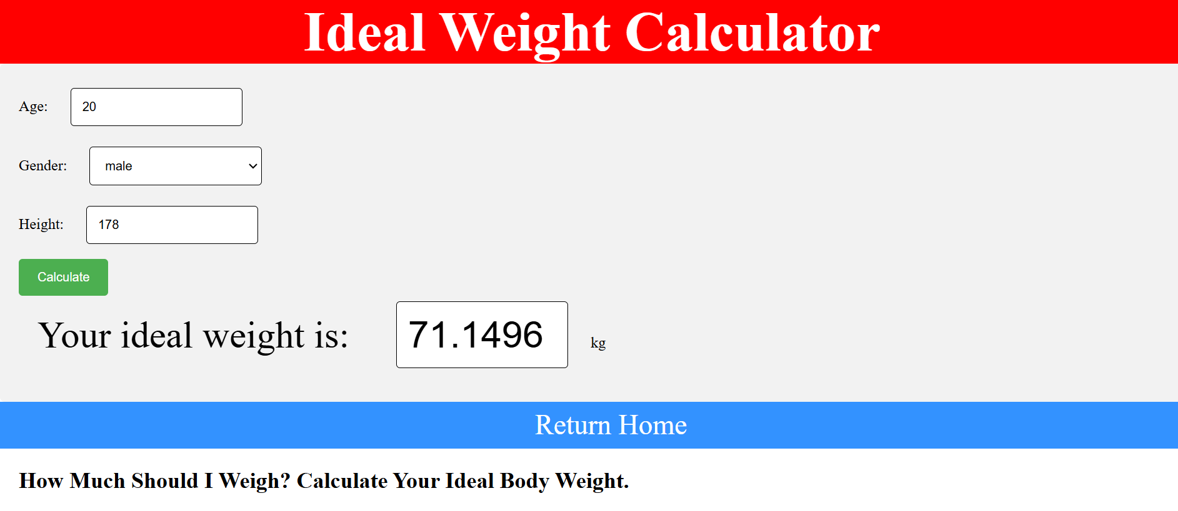
The Ideal Weight Calculator provides an estimate of what may be a healthy weight range based on your height. While it’s a general guide, it can be helpful for setting realistic fitness goals.
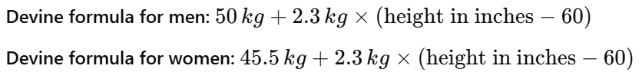
Formulas:

For athletes and bodybuilders, the concept of "ideal weight" differs from that for the general population, as athletes often have specific needs based on their sport, body composition, and training goals. An athlete’s ideal weight should focus more on body composition, sport demands, and performance outcomes than on traditional metrics alone.

Contact
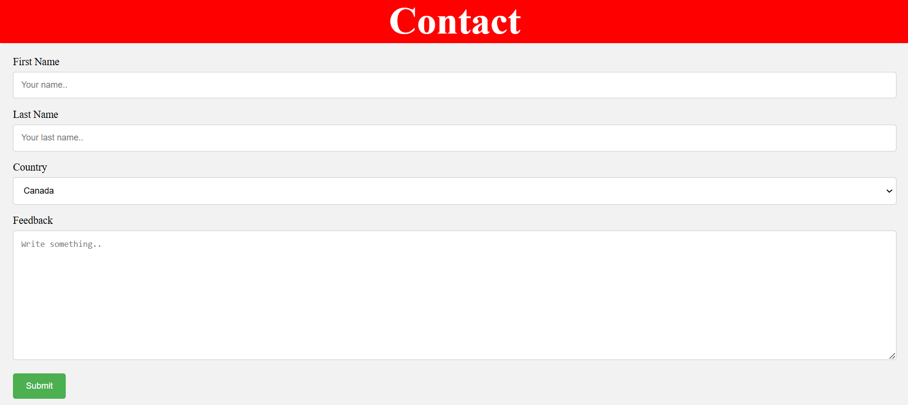
When users have questions about fitness calculators, feedback, or anything else, they can contact me through the contact form.

